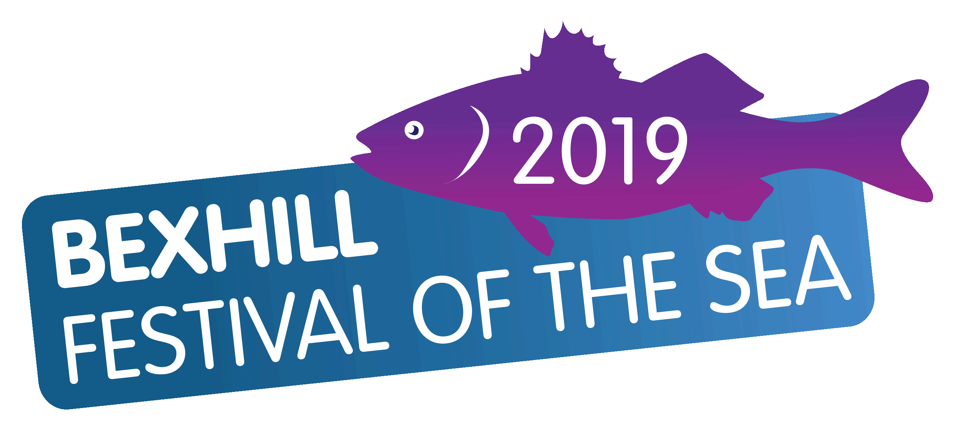
BEXHILL FESTIVAL OF THE SEA 2019
Angling Competitions from 8th Sept to 20 October
Weekend Festival 7th & 8th September

Angling Competition Entry Form

Please enter me in the following competitions:
Junior Pegged Beach Match  Sunday 29th September (11 am – 2 pm) | Entry £ 5 | Separate Form Required
Boat Species Hunt – FLATFISH ONLY  Sunday 8th September (9am to 5pm) | Entry £15 | Yes / No | £
Beach Specimen Hunt – 5 Days  Monday 30th September Start 9am to  Friday 4th October 5pm  (Photo - Catch & Release) | Entry £15 | Yes / No | £
Pegged Open Beach Match)  Sunday 13th October (9am to 2pm)  Penn Points Match | Entry £20 | Yes / No | £
Bass Specimen Hunt  (Catch & Release)  Sunday 20th October (11 am – 3 pm) | Entry £15 | Yes / No | £

Total enclosed £ _____________

Please print clearly in block capitals. See web site for competition rules. Junior (Under 18) Lady

Name
Address
Town |  |  | Post Code
Telephone | Home: |  | Mobile:
Club/Association
(if applicable)
Email Address
I have read and retained the competition rules and agree to abide by them. I agree that the organisers shall not be held responsible for any loss, accident or damage to any competitor, official or member of the public.
Signed: _____________________________________________
Please tick box if you would like us to keep your information for future events. We respect your privacy and will not forward your information to any third party.
Please complete and send with cheque made payable to Bexhill Festival of the Sea to:

Reeders, 16 Calvert Close, West Park, Uckfield, East Sussex , TN22 2BZ or deliver cash or cheque to Anglers Den.
Bank transfer details by request. Telephone: 01825-769240 or 07917-863175
